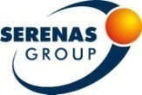
Three days in İstanbul: Basic Molecular Pathology Course
with "Hands On" Interactive Practice
September 19-21, 2013
Anadolu Medical Center / GEBZE

REGISTRATION & ACCOMMODATION FORM

Serenas Tourism is the official agent for the Basic Molecular Pathology Course with "Hands On" Interactive Practice to be held in Gebze, Turkey. Please complete this form and return it to Serenas Tourism. All communications should be done with Serenas Tourism.

IDENTIFICATION
Title: Mr. Ms. Prof. Dr.
Family Name: First Name: Middle Name:
Academic Title:
Certified Specialty or Professional Sector:

Mailing Address:
City State/Country Zip/Postal Code
Telephone: Country Code City Code Number
Fax: Country Code City Code Number
E-mail Address:

REGISTRATION

Theoretical Part: 175 Euro Practical Part: 100 Euro
(Registration for practical part has been completed.)
- %18 VAT is included.

HOTEL ACCOMMODATION

Holiday Inn Gebze İstanbul Asia  http://www.higebzeist.com/en/ |  | Single Room | Double Room*
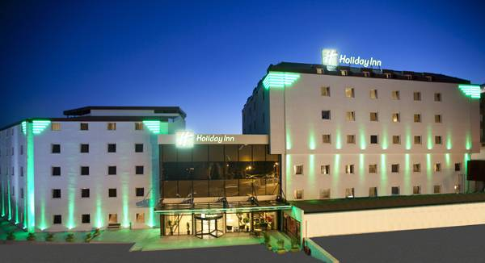 | Available within 18-21 September 2013 | 100 Euro | 125 Euro
The Green Park Pendik Hotel  http://www.thegreenparkpendik.com/ |  | Single Room | Double Room*
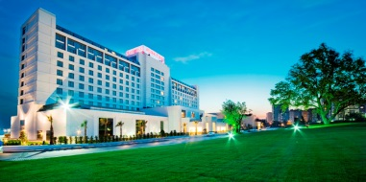 | Available within 18-21 September 2013 | 120 Euro | 150 Euro
Divan İstanbul Asia  http://www.divan.com.tr/ENG/Hotel-Destinations/Divan-Istanbul-Asia/ |  | Single Room | Double Room*
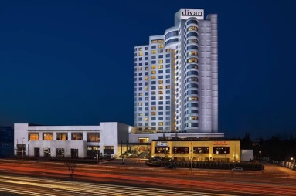 | Available within 18-21 September 2013 | 100 Euro | 125 Euro

Emex Otel İstanbul  http://ist.emexotel.com/ |  | Single Room | Double Room*
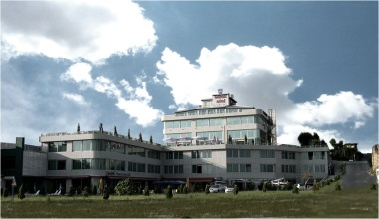 | Available within 18-21 September 2013 | 70 Euro | 100 Euro

- Above pricelist is given in EUR, per night.
- The price includes a breakfast. %8 VAT is not included.
- All reservations are to be made directly through Serenas Tourism for these prices.
- Before sending your form, please check the availability of your selected hotel with Serenas Tourism. Hotel confirmation will be sent to you according to availability. If the hotels are fully booked, Serenas Tourism will send you an information e-mail to select another hotel option.
- Hotel reservation will be finally confirmed when payment of the 100 % for the ordered services is made not later than 10.08.2013.
- Sending a reservation form after 10.08.2013 clients will be suggested any rooms that left with individual renegotiated reservation terms.

* For Double Room; I will share my room with; Name: Last Name:

SOCIAL PROGRAMME – 1

Dinner and cruise on Bosphorus Istanbul by night: Dinner Cruise along the Bosphorus
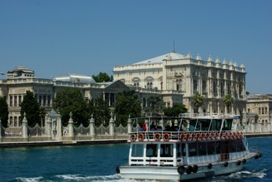 | September 19, 2013 (Thursday night) at 20:00 | 30 Euro 1 pax  60 Euro 2 pax  90 Euro 3 pax

SOCIAL PROGRAMME – 2

Dinner: A Taste of Authentic Turkish Food
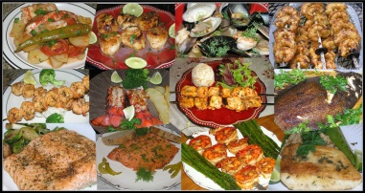 | September 20, 2013 (Friday night) at 20:00 | 30 Euro 1 pax  60 Euro 2 pax  90 Euro 3 pax

- %18 VAT is not included.

REQUEST FOR TRANSFER

Name (As reflected on air ticket:

Number of accompanying persons:

AIRPORT - HOTEL TRANSFER 1 - 90 Euro

Arrival transfer : Yes No

Arrival date : /09/13

Airline | Depart Time | Arrival Time | From | To | Flight number

HOTEL- AIRPORT TRANSFER 2 - 90 Euro

Return transfer : Yes No

Return date : /09/13

Airline | Depart Time | From | To | Flight number

- %18 VAT is not included.

PAYMENT
Accommodation Fee: Euro (Check-in on: /09/13 , Check-out on: /09/13)
Tax of Accommodation %8: Euro

Registration Fee: Euro

Social Programme-1 Fee: Euro
Tax of Social Programme-1 %18: Euro

Social Programme-2 Fee: Euro
Tax of Social Programme-2 %18: Euro

Transfer 1 Fee: Euro
Tax of transfer 1 %18: Euro

Transfer 2 Fee: Euro
Tax of transfer 2 %18: Euro

TOTAL: Euro

CREDIT CARD

I hereby authorize SERENAS Tourism (Serenas Uluslararası Turizm Kongre Org. A.Ş.) to have my credit card charged for the amount of Euro, which has the details below.

Type of Credit Card: Visa Master Card
Card holder’s name:
Card number*: / / / *Just add 4 number for each box
Expiry Date:
Card Validation Code**: ** The last three digits of the number at the back of the card
Digital Signature: By clicking this box I authorize SERENAS Tourism to charge the above credit card for the balance of my account
Card Holders Signature: ------------------------------------------

BANK TRANSFER

Account Name: SERENAS International Tourism Congress Org. (SERENAS Uluslararası Turizm Kon. Org. A.Ş.)
Name of the Bank : HSBC BANK A.S. Branch Name: ANKARA KURUMSAL SUBE
Swift Code: HSBCTRIX Branch Code: 106 EFT Code: 123
Branch Address: NERGIZ SOK. BAYRAKTAR VIA TOWER K:12 SOGUTOZU ANKARA

TL Account No : 106-1026635-282 TL Iban No : TR390012300106102663528200

Euro Account No : 106-1026635-773 Euro Iban No : TR810012300106102663577399

Important Note: Participants who pay their balance with a bank transfer are required to send the bank receipt copies to SERENAS Tourism via fax or mail with this form, confirmation will be sent in 7 days.

In the event of VAT increasing, the resulting increase will be passed on to the client

Please type or print this form clearly in block letters and fax to the + 90 ( 232 ) 486 03 70

SERENAS International Tourism Congress Org.
Address: Mansuroğlu Mah. Ege Sun Plaza A Blok Kat 7 No 762 Bayraklı İzmir / TÜRKİYE
Phone:+ 90 (232) 486 03 03 Fax: + 90 (232 ) 486 03 70

Url: www.serenas.com.tr E-mail: cuneyt.ozbilgin@serenas.com.tr

CANCELLATIONS AND REFUNDS

All cancellations must be made by sending an email to the address cuneyt.ozbilgin@serenas.com.tr , for all notifications of cancellation, please make a reference to a bank account, including the Swift Code, where a possible refund may be remitted less bank charges. In the event that a cancellation of a booking is requested, the cancellation fee will be charged according to the following schedule:
Days Prior to 18 September 2013 | Cancellation Fee
71 days or more | Handling Fee*
70 to 30 days | 50% of total price
29 to 0 days | 100% of total price
No Show | 100% of total price

*Handling Fee: 50 € for per person
- Please note that all refunds will only be processed after the completion of the course.

